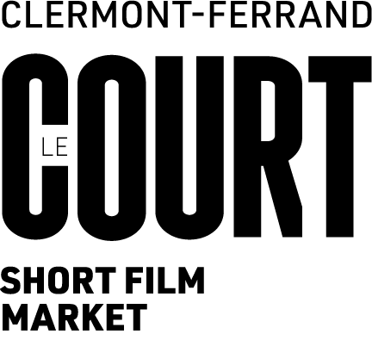 |  | EURO CONNECTION XIX  2-3 February 2027 – Clermont-Ferrand

Entry Form – Euro Connection 2027

Short film project
Original title:
English title:
Director:
Script written by:
Producer (full name):
Production company:
City: Country:
Website/socials :

Contacts
Producer’s e-mail Cell phone:
Director's e-mail: Cell phone:

Tech specs
Estimated running time:
❒ fiction  animation  creative documentary
❒ early stage of development  in progress  advanced stage of development
Planned period of shooting (after June 2027):
Planned completion date:

Short synopsis (500 characters):

Budget and financing
Total estimated budget (in €)
Secured funding to date (in €): (i.e. …….. % of budget)
❒ I declare that project has secured partial funding from an external source.
Name of funding body:
Granted on (date):
Type of funding received (please tick where appropriate):
❒ script / development grant  for production  other : ……………………………………
Source of funding:
❒ national fund   local/regional/city fund  broadcaster / TV coproduction support/presale
❒ prize/award/foundation money  other (specify:…………………....................................)
Recipient of funding: …………………………………………………………………………………………….

Partner(s):  Project has no other EU or international coproduction partner at time of application
❒ Project has one EU or international coproduction partner at time of application
Co-production partner : …………………………………………….. Country:………………………………

Director’s bio - please specify your birth year (750 characters) :

Producer’s bio - please specify your birth year (750 characters) :

Profile of production company (500 characters):

Please add following documentation for your application to be valid:
- Filled-out form (pp. 6-7 only from this document)
- Complete script.
- Director's note (artistic choices – 1 page max.).
- Producer’s note (including coproduction strategy – 1 page max.).
- Proof of funding granted by third party organisation (confirmation letter, etc.).
- CV and photo of director.
- CV and photo of producer.
- Video link to previous film (or clips) by same director (if available).
- Filmography and logo of production company.
❒ I understand and accept that the information contained in this form will be published if my project is selected and might be edited to match Euro Connection guide publication requirements.
❒ I commit to attend Euro Connection in person (Jan 31- Feb 4, 2027) in Clermont-Ferrand in case of selection by the European Jury.

Please note: Submitting this application means you will also be considered for the Road to Euro Connection/Italy programme, that gives you access to a wide set of opportunities for your short film. If you do not wish to be considered for this programme, please indicate that here.

I WANT / DON’T WANT to be considered for Road to Euro Connection/Italy

Producer’s full name:

Date: Signature:

Send your application by e-mail to your national correspondent in one single PDF file

